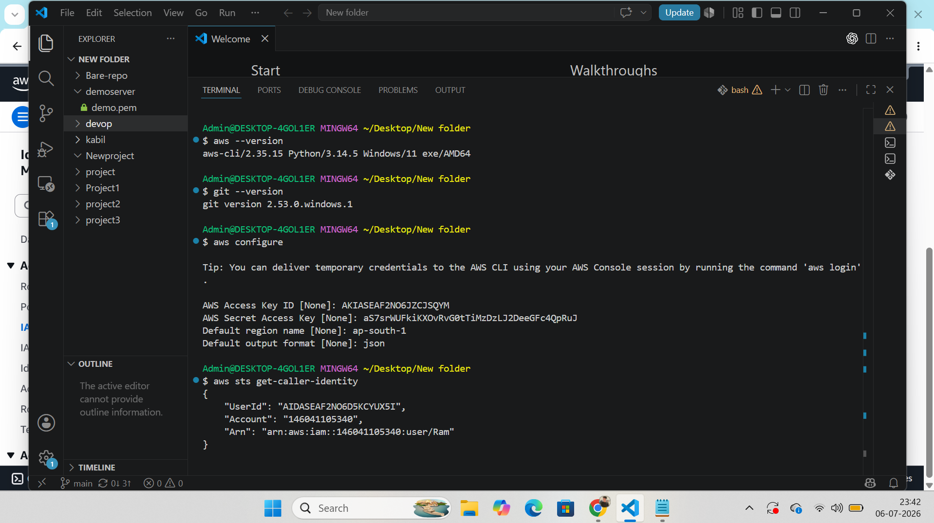

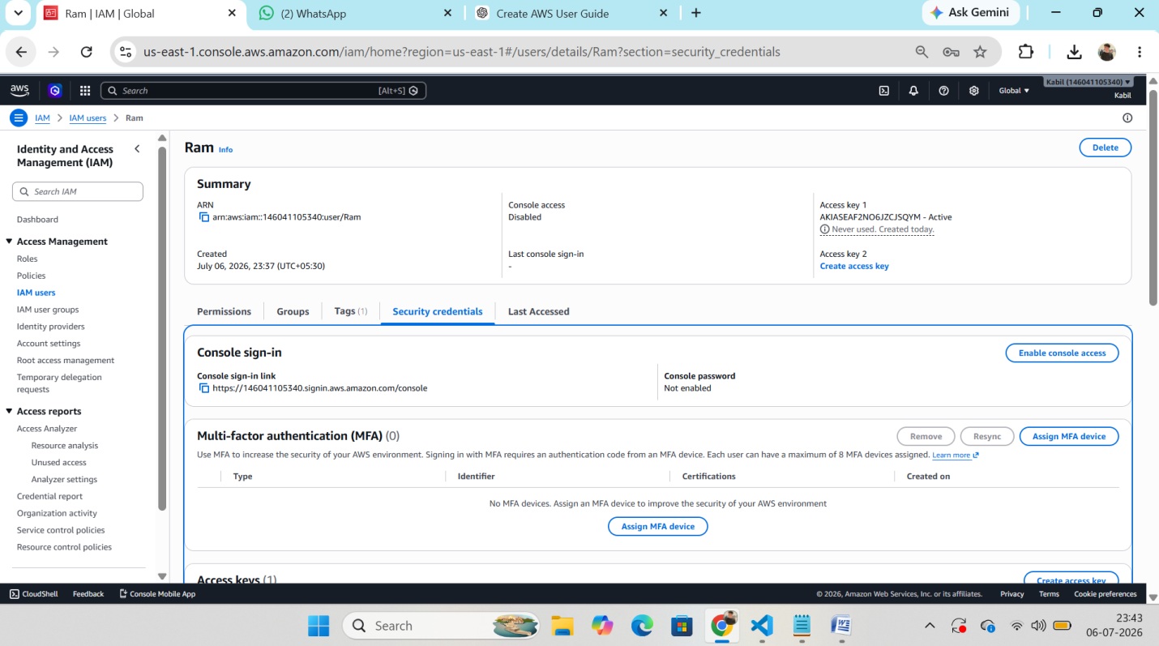
Step 1: Install the AWS CLI on local machine.
Step 2: Create a new IAM user and generate an Access Key ID and Secret Access Key. Save both credentials.
Step 3: Configure the AWS CLI:
aws configure
Enter:
- Access Key ID
- Secret Access Key
- Default Region (e.g., ap-south-1)
- Output Format (json)
Step 4: Verify the connection:
aws sts get-caller-identity

